CNT3004: Computer Network Concepts
Homework 1

Name: ____________Zachary Taylor_______ PID: ____4107821________________

- Answer each question briefly, but completely. When computing an answer, make sure to show how you arrived at your answer. For the hands-on portions, follow the directions but make sure to take a screen shot of your results and paste into your submitted document. You may need to Google some of the question topics.

- How many layers are defined in OSI model? List them from top to bottom.
OSI has 7 layers: application, presentation, session, transport, network, data link, physical.
- How many layers are defined in TCP/IP model? List them from top to bottom.
There are 4 layers. Application, transport, Network, Link.
- How many bytes are used for a MAC address? How many bytes are used for an IPv4 address? What about an IPv6 address? How many bytes are used for a port number?
There are 6 bytes in a MAC address. IPv4 has 4 and IPv6 has 16. A port number has 2 bytes.
- Comparing the star topology and the bus topology in constructing a LAN, which one is better? Why?
Star topology: multiple devices are connected to a central hub which controls the traffic.
- More expensive
- Faster data transmission
- Traffic management is dependent on hub (is better than BUS in general)
- Expansion is easier
- Less data collision
- Troubleshooting faults is easier
Bus topology: multiple devices are connected to a backbone cable with two terminators.
- Cheaper
- Higher chance of data collision
- Slower data transmission
- Almost nonexistent traffic management ability
For a Lan network, and with the above pros and cons in mind, it would be better to use Star topology.

- Assume seven devices are arranged in a mesh topology. How many cables are needed? How many ports are needed for each device?
In total: 49 cables are needed and each device needs 7 ports.
- When connecting devices in a network, you need a switch. When do you need a router?
Since a router is designed to connect multiple switches, you would want to use a router when you have a very large network, or need to make a network of networks.
- What is encapsulation and de-encapsulation? How is it used in a network?
Encapsulation and de-capsulation refer to the process in which protocol information is added or removed from the data as it passes through network layers. This adds security in such a way that one can verify the contents of the data and maintain privacy.
- Assume that the number of users of the Internet at the beginning of 2015 (January 1) is 250 Million. If the growth of users increases 15% per year, how many users will be using the Internet at the beginning of 2021 (January 1)
At the beginning of 2021, assuming that a years worth of growth doesn’t occur in one day, there should be around 578,265,192 rounded up since you can’t have .4 of a person.

- In the TCP/IP protocol suite, the Network layer is primarily responsible for what tasks? Name the main protocols that function at the Network layer.
The network layer defines how data should be sent, is responsible for transmission between devices, and performs its function through encapsulation and IP address mapping. That is achieved through Internet protocol (IP), the Address Resolution Protocol (ARP) protocol, and the Internet Control Message Protocol (ICMP) protocol.

- Assume we need to download text documents at the rate of 500 pages per second (each page is 24 lines with 80 characters per line (8 bits per character)). What is the required bit rate of the channel?
8*80*24*500 = 7,680,000 bits/seconds

- Download and install Wireshark on your computer. Go to https://www.wireshark.org/download.html and download the correct version for your computer. Release 3.2.6 is the Stable Release (as of 8/23/20). When you download, just use the defaults (if you want a desktop icon, make sure to check the box when you get to Additional Tasks during the installation). Once you have completed the installation, open the program, and take a screen shot and paste in your assignment to prove that you have completed the installation.
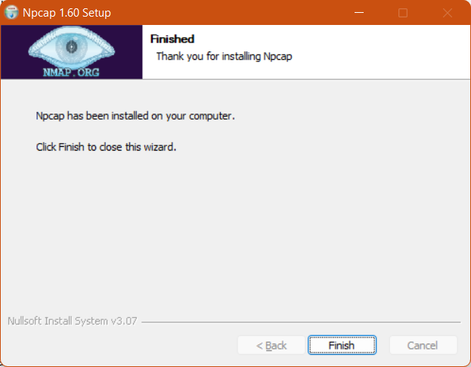
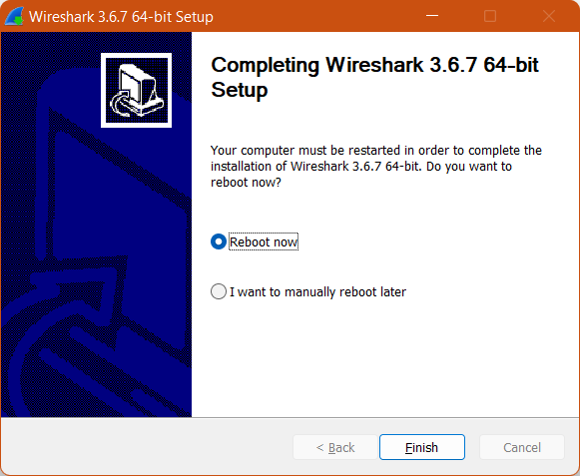
- Using your computer, go to a Command prompt (in Windows type Command in the Search bar at the bottom left of your screen).
  - Type Ping 127.0.0.1 and take a screen shot of the results.
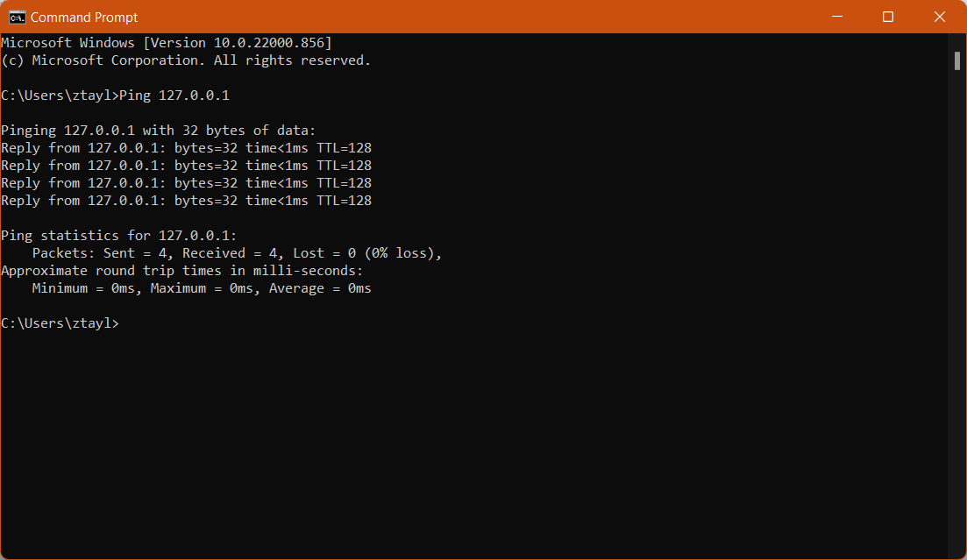
  - Type Tracert www.amazon.com and take a screen shot of the results.
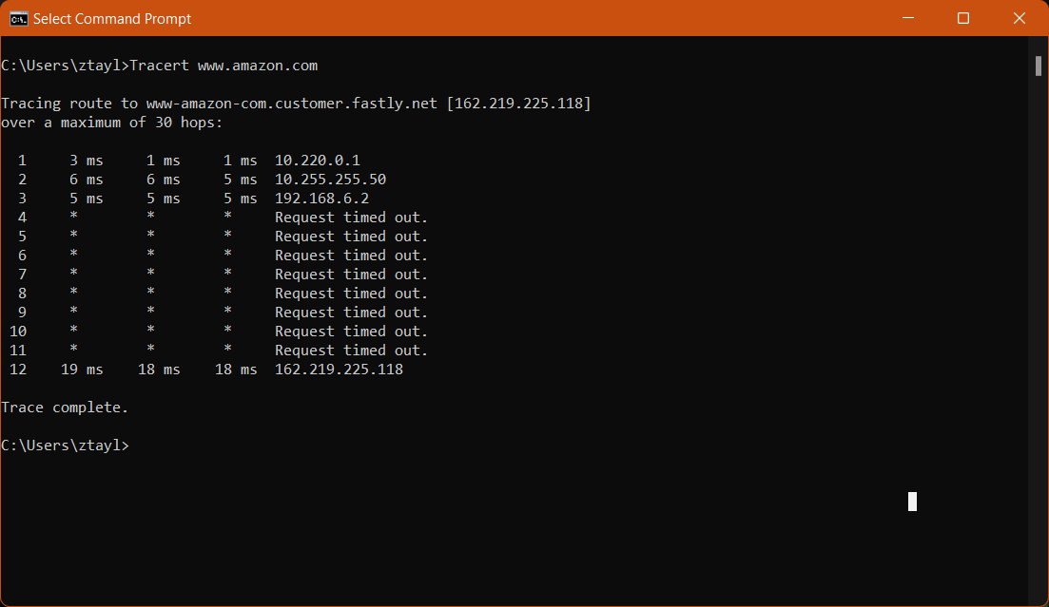
  - Type Tracert www.ucf.edu and take a screen shot of the results.
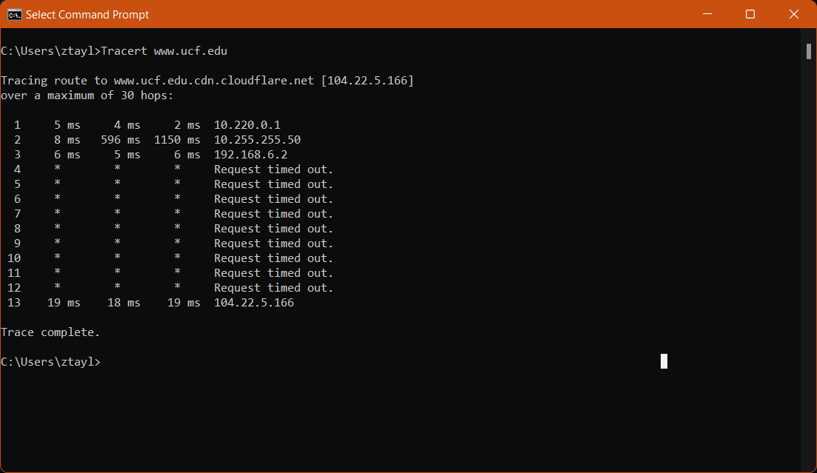

- Using your computer, go to a command prompt (same as #14).
  - Type route print –take a screen shot of the results.

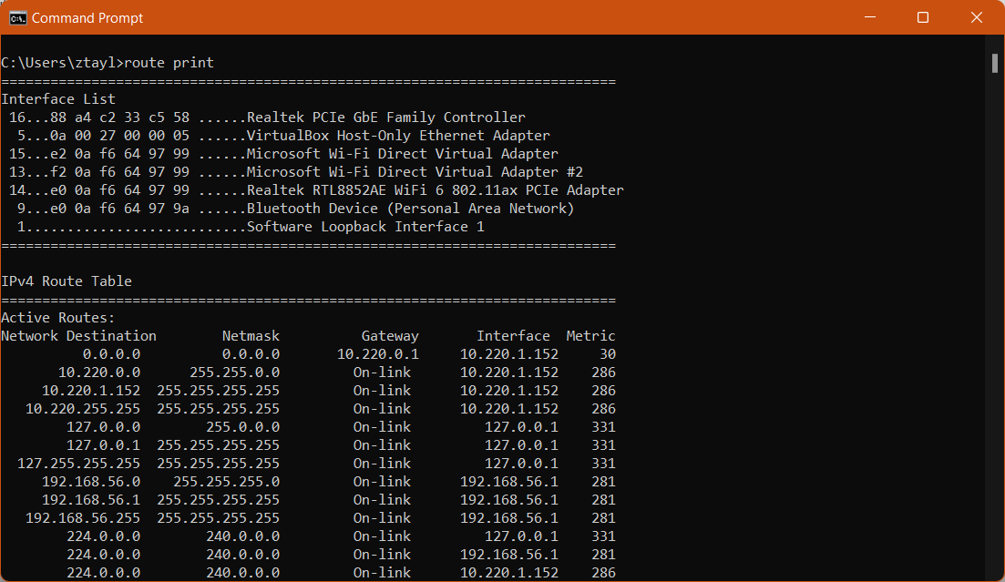
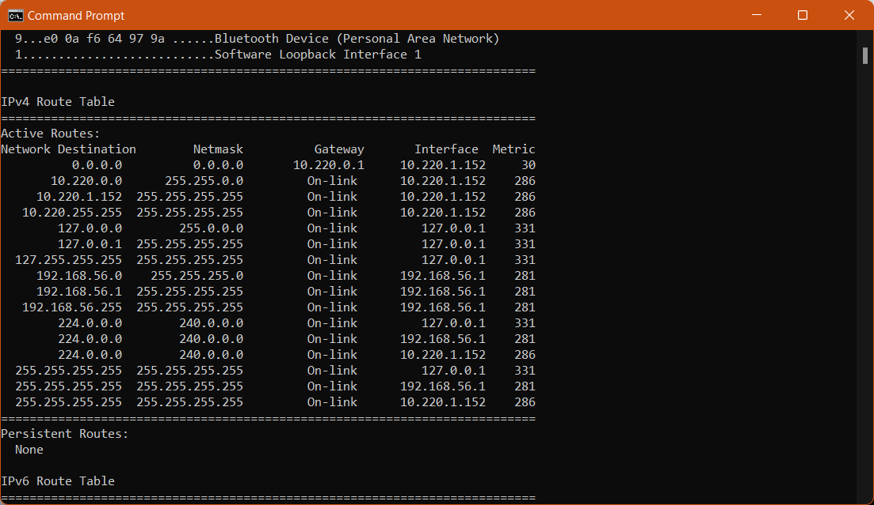
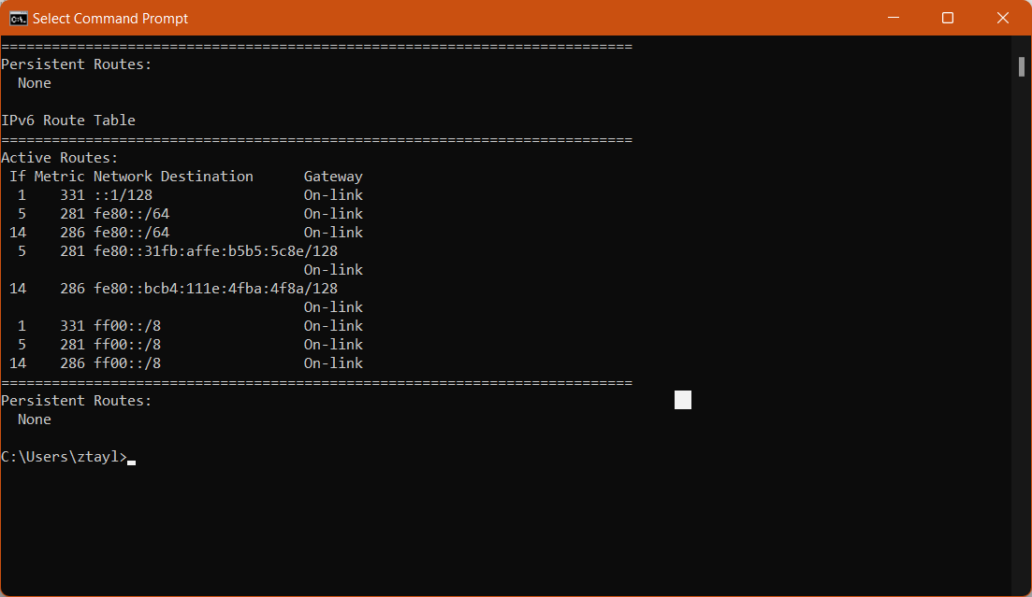

  - Type ipconfig /all - take a screen shot of the results.
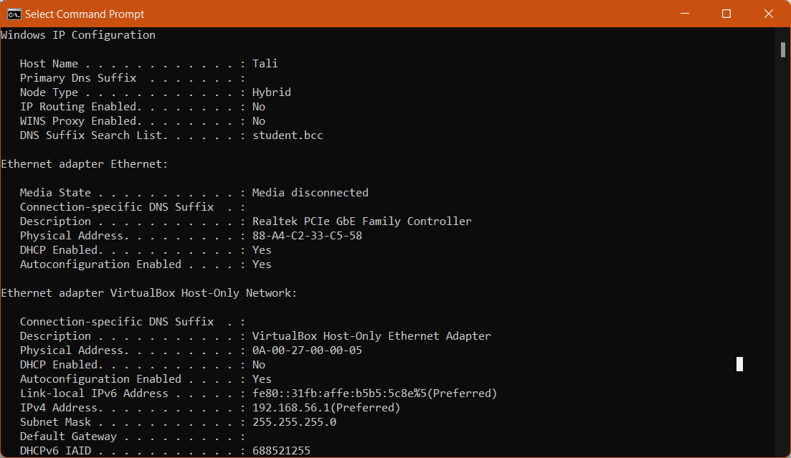
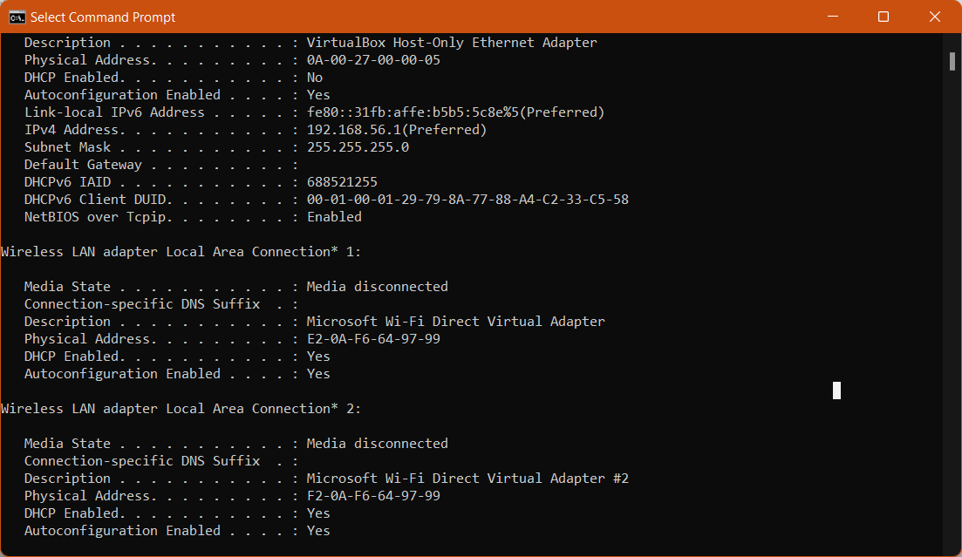
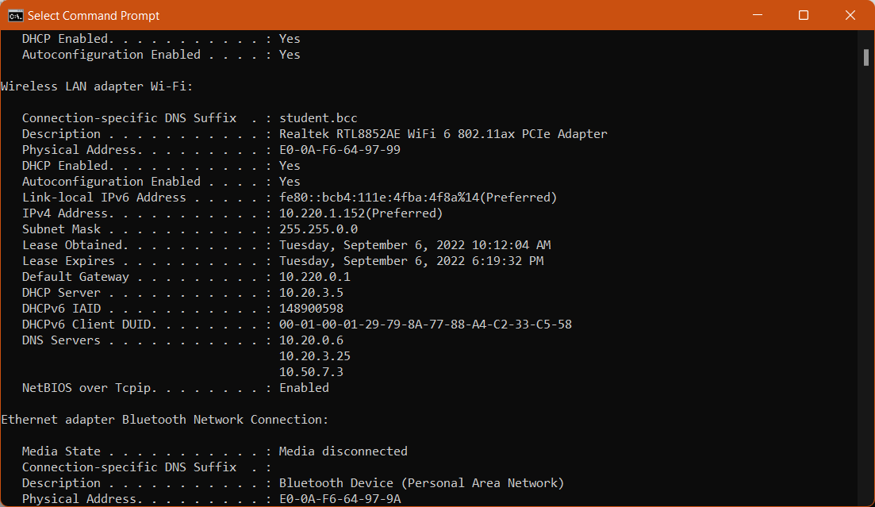
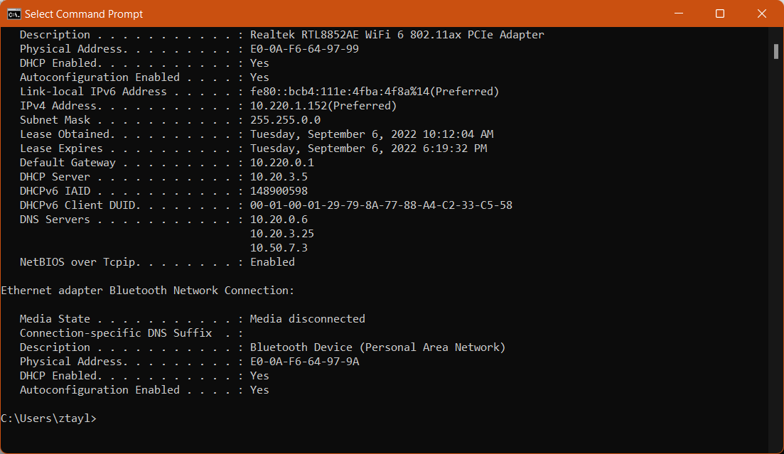

  - Type getmac - take a screen shot of the results.
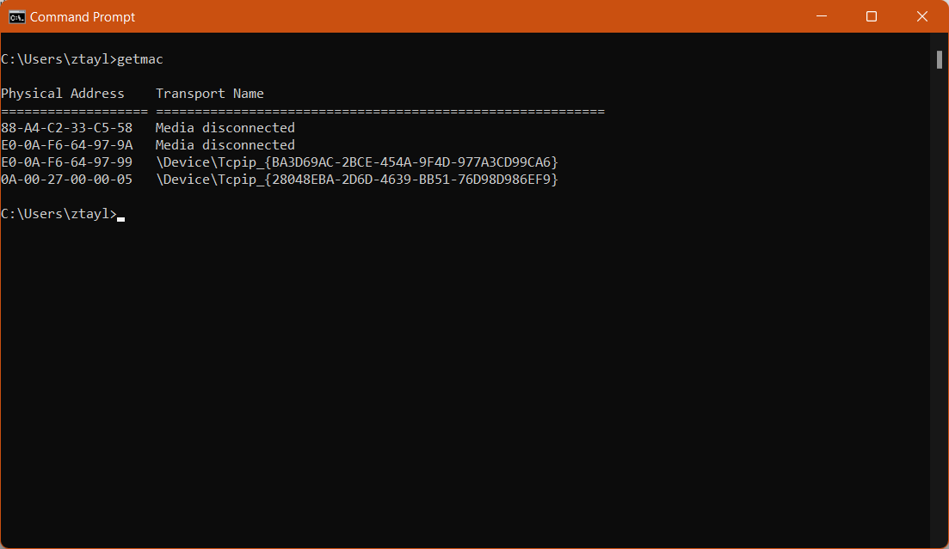

  - Type hostname - take a screen shot of the results.

